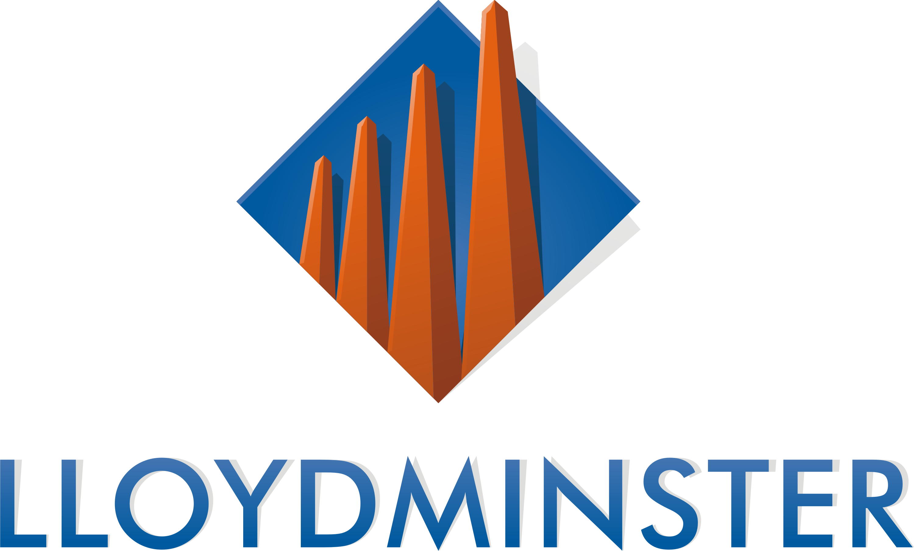

Safe and Healthy Communities Grant

Guidelines & Application

Program Cycle: June - December 2025

Deadline for Submission:
12:00 PM
Monday, May 19, 2025

Submit to:
E-mail: fcss@lloydminster.ca

OR

Mail/Drop-off:
Safe and Healthy Communities Grant
Attention: Patrick Lancaster
City Hall
4420 50 Avenue
Lloydminster, AB
T9V 0W2

For more Information:

Contact the City of Lloydminster at 780-875-6184 Ext. 2909 or
fcss@lloydminster.ca

www.lloydminster.ca/grants

PURPOSE & ELIGIBILTY

The Safe and Healthy Communities Grant (SHG) is a community grant program aimed at enhancing the health, wellness, and safety of residents.

The City of Lloydminster receives funds from tobacco and cannabis retailers through business license fees, which are then distributed to local non-profit organizations to support their programs.

To be eligible for grant funding:
- The applicant must be:
  - An incorporated Alberta or Saskatchewan non-profit organization;
  - A charitable organization; or
  - A school or school division.
- The project must take place within Lloydminster city limits.

Projects must align with at least one (1) of the following objectives:
- Provide knowledge and understanding of the harms and risks associated with addictive substances;
- Support the cessation of the use of addictive substances;
- Promote the adoption of healthy, substance-free lifestyles; or
- Provide education to recognize risks, make informed choices, and consider the consequences of decisions and behaviors.

The following expenditures are INELIGIBLE for the grant:
- Alcoholic beverages, cannabis products, tobacco, tobacco substitutes, or vaporizers intended for consumption.
- Subsidization of wages for permanent employees;
- Donations or projects primarily focused on fundraising;
- Medical research;
- Capital expenses, such as purchasing equipment, construction and renovation expenses, retrofits, and repairs to buildings;
- Costs to sustain the organization outside the direct delivery of the program, including but not limited to property taxes, audit costs, and utilities;
- Direct religious activities;
- Activities designed to directly advocate for or influence municipal, provincial, or federal government legislation, acts, or policies; or
- Activities exclusive to a specific family, business, religious, or political group.

OBLIGATIONS OF GRANT RECIPIENTS

Approved programs will initially receive 75% of the grant funds. Upon receipt of a satisfactory Project Report, the remaining 25% will be distributed. Funds will be distributed to the extent they are supported by eligible receipts or financial statements.
Grant recipients must submit a Project Report upon completion of the program, including:
- A completed Community Grant Project Report Form (available on the City of Lloydminster website: www.lloydminster.ca/grants).
- Copies of receipts and payroll records or audited financial statements prepared by a registered Certified Management Accountant, Certified Accountant, or Certified General Accountant (CMA/CA/CGA) to verify expenditures. Payroll records must include timesheets and detailed pay stubs. Note that cheque request forms, general ledger printouts, purchase orders, petty cash vouchers, and cancelled cheques are not eligible for verification of expenses unless supported by actual receipts.
- All eligible receipts must be dated within the grant period, from June 23, 2025 date to December 31, 2025.
- A description of how the City of Lloydminster was publicly acknowledged as the source of funds for the program (samples may be requested).
Complete reporting must be submitted directly to the City of Lloydminster 30 days following the end of the program by Wednesday, January 14, 2026, whichever is earlier. Reports can be submitted via email to fcss@lloydminster.ca or in person at the City Hall reception desk. Any organization that does not provide the required reporting materials may be ineligible for future grant funding administered by the City of Lloydminster. Unused funds or funds used for purposes other than what was approved must be returned.

APPLICANT INFORMATION
Legal Organization Name
Operating Name (if different from above)
Non-Profit Number
Mailing Address
Phone Number

CONTACT INFORMATION
Primary Contact Person and Position
Phone Number
E-mail Address

PROGRAM OVERVIEW
Program Title
Funding Request Amount
Start Date
End Date

ORGANIZATIONAL OVERVIEW

1. Provide a brief overview of your organization (i.e. mission, mandate, goals, programs, etc.).

PROGRAM DETAILS

2. Provide a comprehensive overview of your program. Include the program's objectives, benefits to the participants, benefits to the community, and how you will deliver the program.

Please provide sufficient detail to demonstrate how the program meets at least ONE of the following objectives:
- Provide knowledge and understanding of the harms and risks associated with addictive substances;
- Support the cessation of the use of addictive substances;
- Promote the adoption of healthy, substance-free lifestyles; or
- Provide education to recognize risks, make informed choices, and consider the consequences of decisions and behaviors.

3. Has this program been offered in the past? If so, what have been the successes and/or challenges?

4. Identify the expected number of participants (i.e., per day, per week, minimum, maximum, etc.).
Include information about target demographics, if relevant (youth, seniors, newcomers).

5. Estimate how many volunteers are needed for this program and describe how they will be involved.

6. Identify any partnerships with other organizations that are relevant to this program, if applicable.

7. What outcomes (impact, benefits, and results) do you hope to achieve through this program? How will you evaluate its success?

8. Include any additional comments that the review committee should consider when reviewing your application.

PREVIOUS GRANT CYCLE UPDATE (IF APPLICABLE)

9. If your program was approved for Safe and Healthy Communities Grant funding in the previous cycle (2024), please provide a brief update on its status.

PROGRAM BUDGET

Please complete the following budget for the proposed program only, including as much detail as possible.

- Identify all sources of income, including self-generated revenue, donations, fundraising, registration fees, sponsorships, grants, and other funding sources.
- Identify all anticipated expenditures for the proposed program (i.e. sports/music equipment, facility rental, facilitator/coach/contractor expense, admission fees, advertising, etc.). Please refer to the list of eligible and ineligible expenditures and categorize each expense accordingly and provide as much detail as possible.
- NOTE: Copies of receipts and payroll records or audited financial statements are required to verify expenditures. Payroll records must include timesheets and detailed paystubs.

Sources of Revenue for Proposed Program: | Dollar Amount
 | $
 | $
 | $
 | $
 | $
Total Revenue Before Safe and Healthy Communities Grant Request | $
Safe and Healthy Communities Grant Request | $
Total Revenue from All Sources | $

Expenditures for Proposed Program: | Dollar Amount
 | $
 | $
 | $
 | $
 | $
 | $
 | $
 | $
 | $
 | $
Total Expenditures | $

DECLARATION

In making this application, we hereby represent to the Safe and Healthy Communities Grant and declare that, to the best of our knowledge and belief, the information provided is truthful and accurate. The application is submitted on behalf of the named organization with the full knowledge and consent of the Board of Directors. Furthermore, we agree to the following conditions:

- We have read the guidelines and agree to abide by all terms and conditions of the Safe and Healthy Communities Grant.
- We agree to publicly acknowledge the City of Lloydminster as a source of funding for the program.
- Grant funding, if approved, is based on the details provided in this application. The City of Lloydminster must be informed of any material changes to the program, and continued funding will be at the City’s discretion.
- A Project Report is required by Wednesday, January 14, 2026, and must be submitted via email to fcss@lloydminster.ca or in person at the City Hall reception desk. Any organization that fails to submit the required report may be ineligible for future grant funding administered by the City of Lloydminster. Unused funds or funds used for purposes other than those approved must be returned.
- Late applications will not be accepted.

Official Representatives (i.e., Chairperson, Treasurer, Executive Director):

Name: Position:

Signature: Date:

The personal information gathered will only be used or disclosed for the purposes for which it was collected or, in limited circumstances, in accordance with the Saskatchewan Local Authorities Freedom of Information and Protection of Privacy Act.

